Fractions
Fraction on the Number Line
We represent whole numbers and integers on the number line. Similarly, we represent fractions on the number line as well.

Problems: Draw number lines and locate the points on them : 1/4
The denominator is given as 4. So, the unit length between two numbers will be divided into 4 equal parts.
¼ means one part out of four. So, it is marked on the number line at ¼ and it lies between 0 and 1.
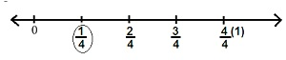
Problems: Draw number lines and locate the points on them : 8/5
The denominator is 5. Now, the unit length between two numbers will be divided into 5 equal parts.
Now 8/5 is located on the number line between 1 and 2.
